<https://dev.ti.com/tirex/explore/node?node=A__AC2MPCw.Xp8nOyVOEpLXIA__com.ti.mmwave_industrial_toolbox__VLyFKFf__4.9.0>

Optimal angle:

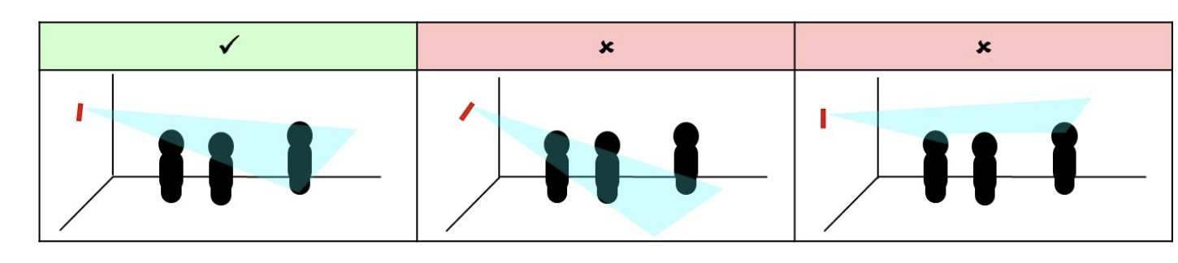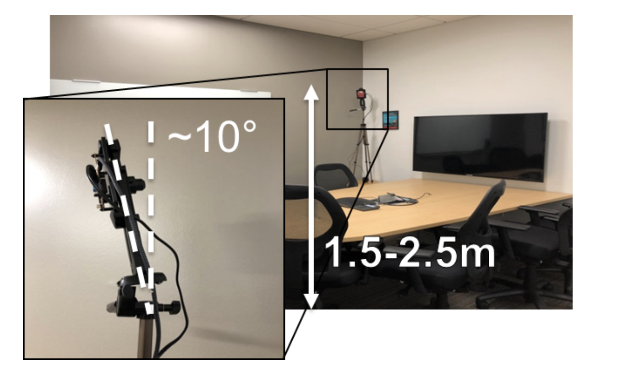

Suggested configuration settings

